**Specification Document**

This project is developed by Kalviyarasi M

Source code:

https://github.com/kalviyarasi/Practise_project

**Output Screenshots:**  
If the user is using this portal for first time, then user needs to register

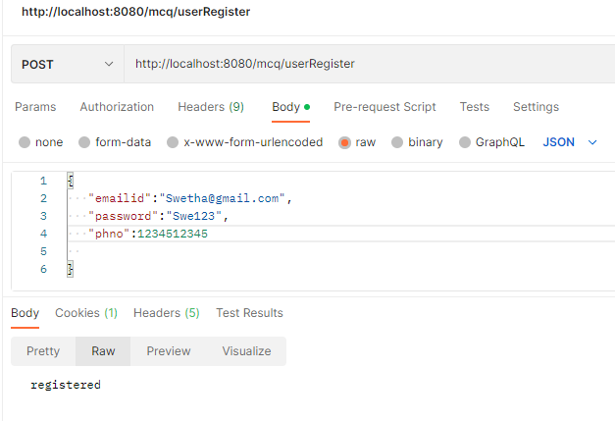

Now the registered user can login using the credentials

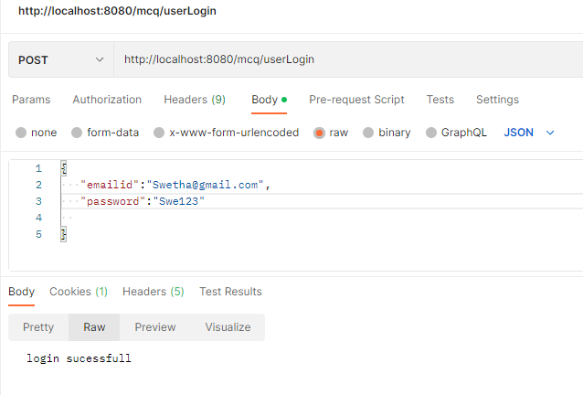

If the user enters the wrong username, it shows as “user not found”

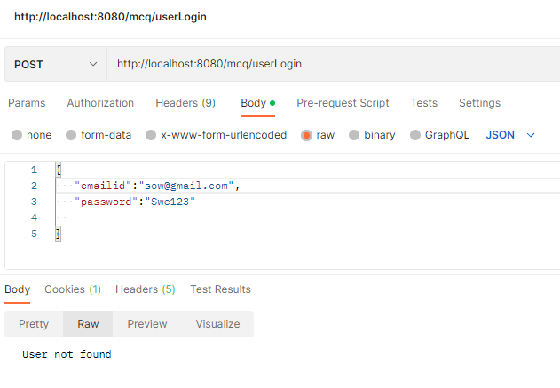

If the user enters wrong password, it will display “invalid credentials”

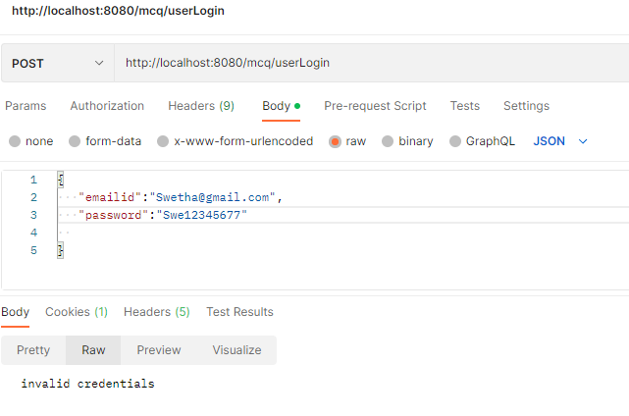

If the registered user tries to register again, it shows “user already exists”

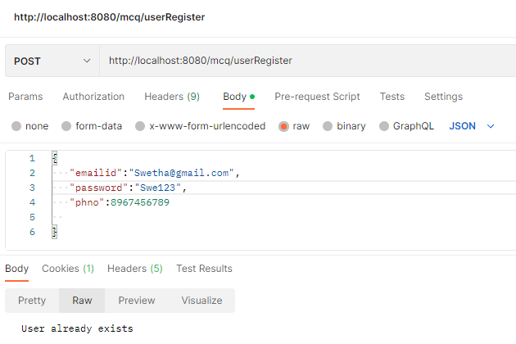

Mysql

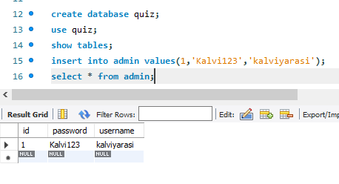

If the user is admin, then can login using admin credentials

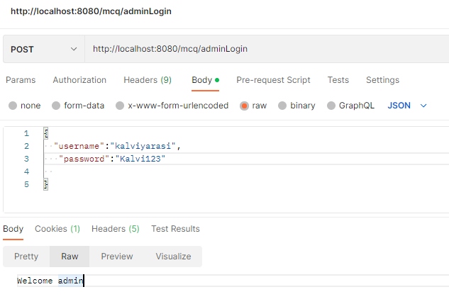

Admin can update the password if needed

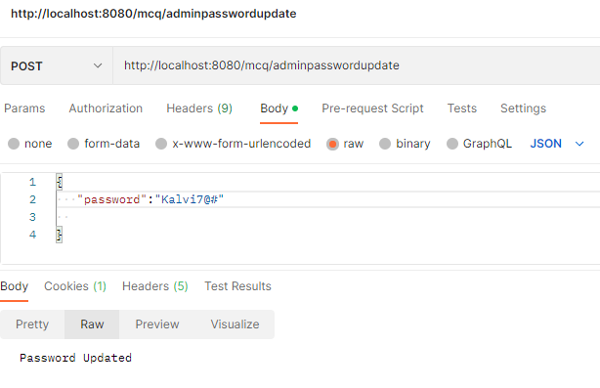

We could see the updated password in the Mysql

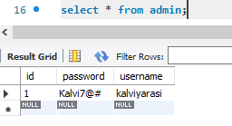

Admin can add a question

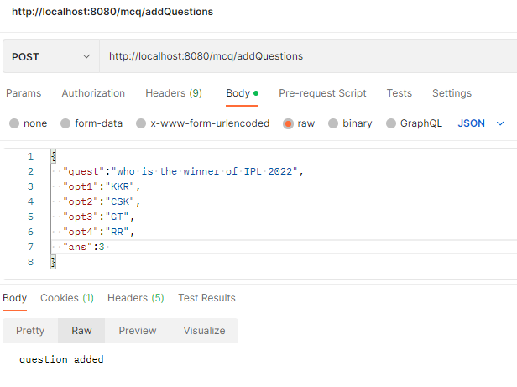

We could see list of added questions in Mysql

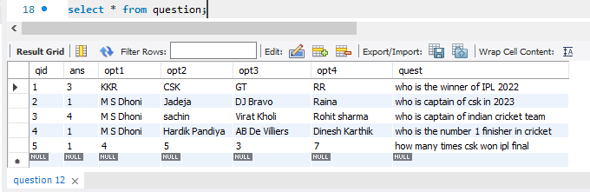

We need to create quiz

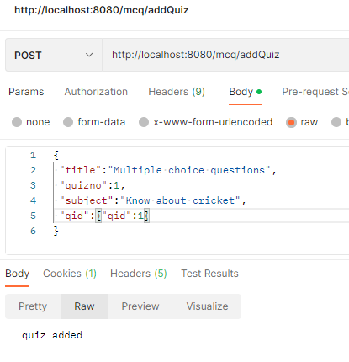

We could see list of quiz in the table

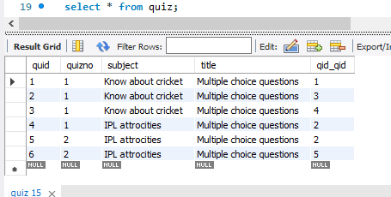

Admin can view all quiz details

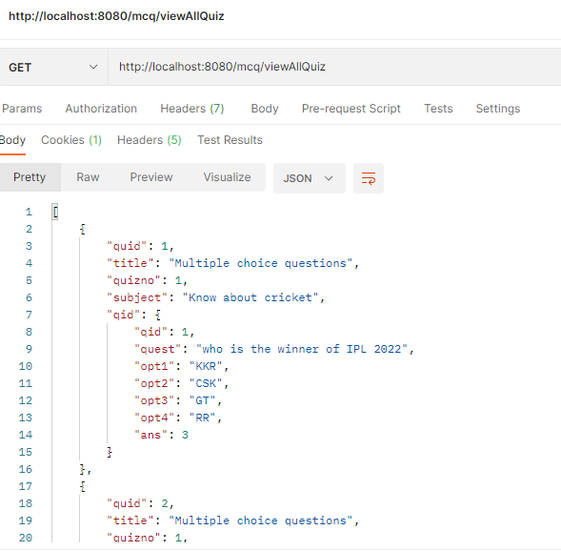

Admin can also see the number of quiz available and user

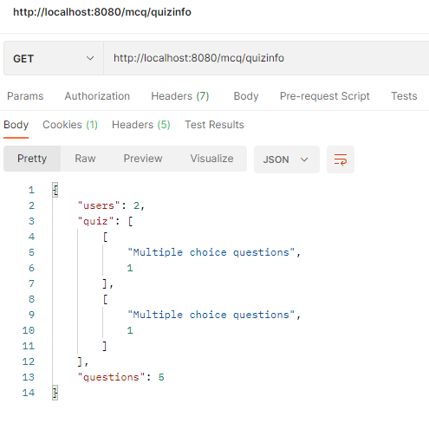

User can take the test using Question Id

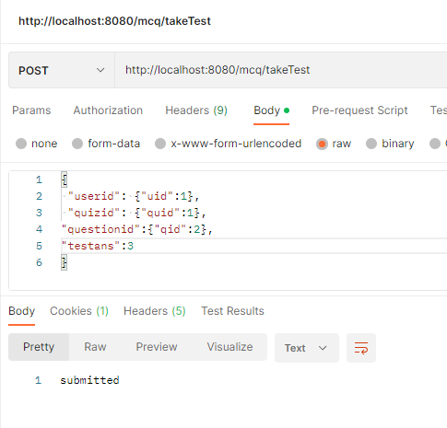

View test details

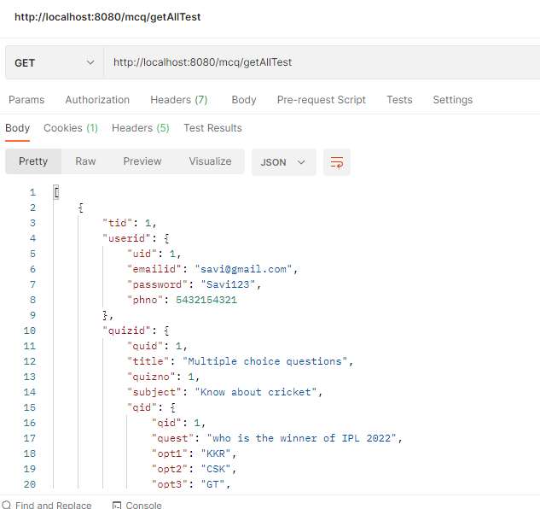

Admin can view the test results

